Practical 1: **Design a Professional Resume**

Aim:

To design a professional resume using online templates.

Objectives:

* To understand professional formatting of resumes
* To identify key resume components
* To export resume in PDF format

Materials Required:

* Computer with internet • Canva / MS Word / Google Docs

Procedure:

# Open the Resume-Designing Application

Start by launching **Canva**, **Google Docs**, or **MS Word** on your computer.

**~**If using Canva, log in with your account and go to the Templates section.  **~**If using Google Docs, open a new document through Google Drive.

**~**If using MS Word, open the application and select “New Document.”

# 1. Browse and Select an Appropriate Resume Template

Navigate to the resume template section. Browse through various designs and choose a template that matches a **professional look**, preferably clean, simple, and easy to read.

~Canva offers a wide range of modern templates.

~Google Docs provides basic but neat resume layouts.

~MS Word includes both modern and classic templates.

# 2. Enter Personal Information

Replace the sample text in the template with your **personal details**, such as:

~Full Name

**~**Contact Number

~Email Address

~Address (optional)

~LinkedIn or portfolio links (if applicable)

~Ensure the information is accurate and formatted consistently.

# 3. Add Academic Details

Insert your educational background in the provided section of the template. Include:

~Course/Program Name

~Institution Name

~Duration (Year of study)

~Grades or CGPA (if required)

~Arrange information in **reverse chronological order** (most recent first).

# 4. Write a Career Objective

Add a short, clear career objective highlighting your goals, strengths, and professional aspirations.

Keep it concise (2–3 lines) and tailored to the field you are applying for.

# 5. Include Skills and Achievements

Create a section for **skills**, both technical and soft skills. Examples:

~Technical skills (e.g., MS Office, programming languages)

~Soft skills (e.g., communication, teamwork)

Add any **academic achievements, certificates, awards, or projects** relevant to your profile.

# 6. Format the Resume Professionally

Adjust the text formatting to ensure clarity and readability:

○ Use **headings** for each section (e.g., Education, Skills, Objective).

○ Use **bullet points** to list items cleanly.

○ Maintain consistent **font style**, **size**, and **alignment** throughout.

○ Ensure proper spacing and margins for a neat layout.

Review the resume for grammatical correctness and visual balance.

# 7. Preview and Make Final Adjustments

Scroll through the entire resume to check layout alignment, spacing, colors, and text placement.

Make sure the document looks uniform and professional before exporting.

# 8. Export the Resume in PDF Format

Once the final layout is ready, export or download the document as a **PDF file**, which preserves formatting.

○ In Canva, click **Download → PDF Print**.

○ In Google Docs, go to **File → Download → PDF Document**.

○ In MS Word, select **File → Save As → PDF**.

**~OUTPUT~**

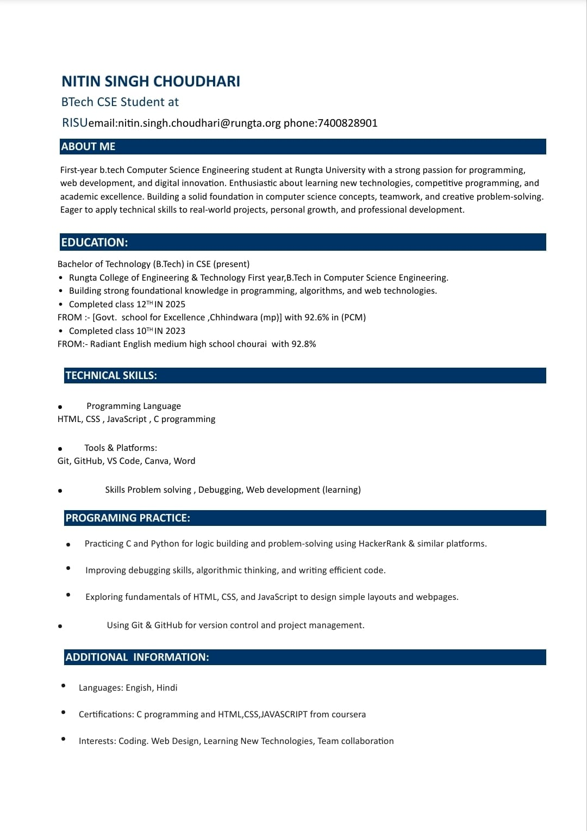

# Practical 2: Career-Oriented Presentation

Aim:

To create a career presentation using slides, transitions, and animations.

Objectives:

* To design a multi-slide professional presentation
* To apply transitions and animations

Materials Required:

* PowerPoint or Google Slides

Procedure:

# Open a blank presentation

Launch PowerPoint/Google Slides and select the option to create a new blank presentation. This opens a fresh workspace where you will design your slides.

# Create a title slide

Insert a title slide layout and add the presentation title along with your name or subtitle. Ensure the title is clear, readable, and visually centered on the slide.

# Add minimum 7 slides

Use the “New Slide” option to insert at least seven additional slides with appropriate layouts. Each slide should focus on a single topic or idea for clarity.

# Insert images, icons, and bullet points

Add relevant images and icons to visually support your content.

Use bullet points to present information in a structured and easy-to-read format.

# Apply a theme

Choose a professional theme from the design options available in the software. The theme will automatically set consistent fonts, colors, and backgrounds.

# Add transitions and animations

Apply slide transitions for smooth movement between slides.

Add animations to text or images to enhance the presentation without overusing effects. **~OUTPUT~**

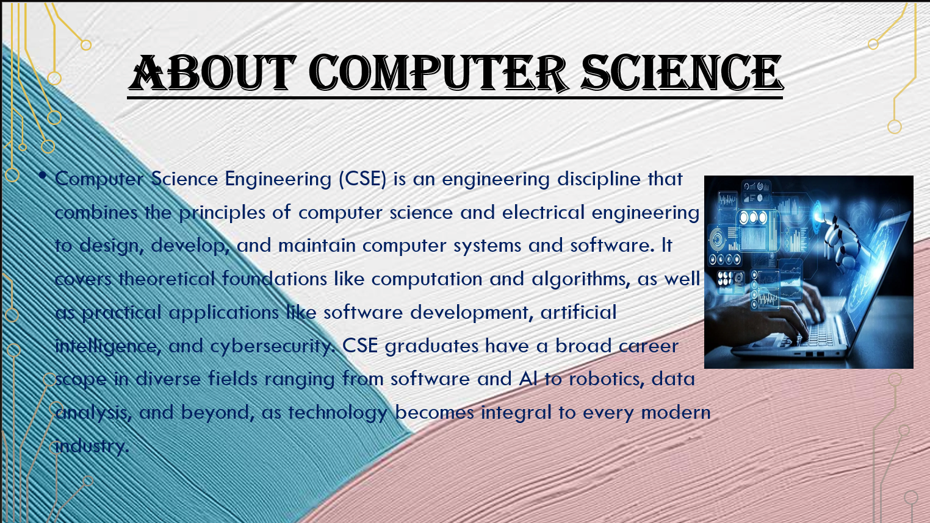

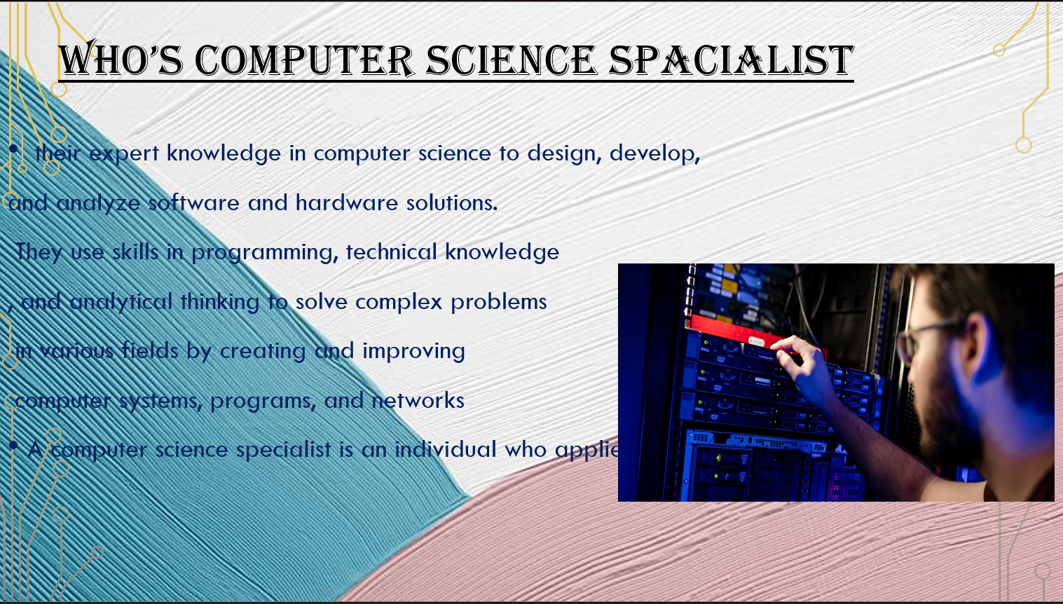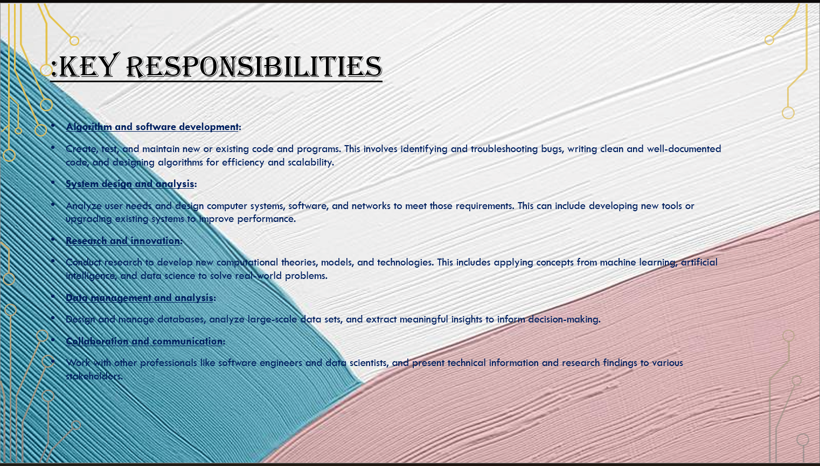

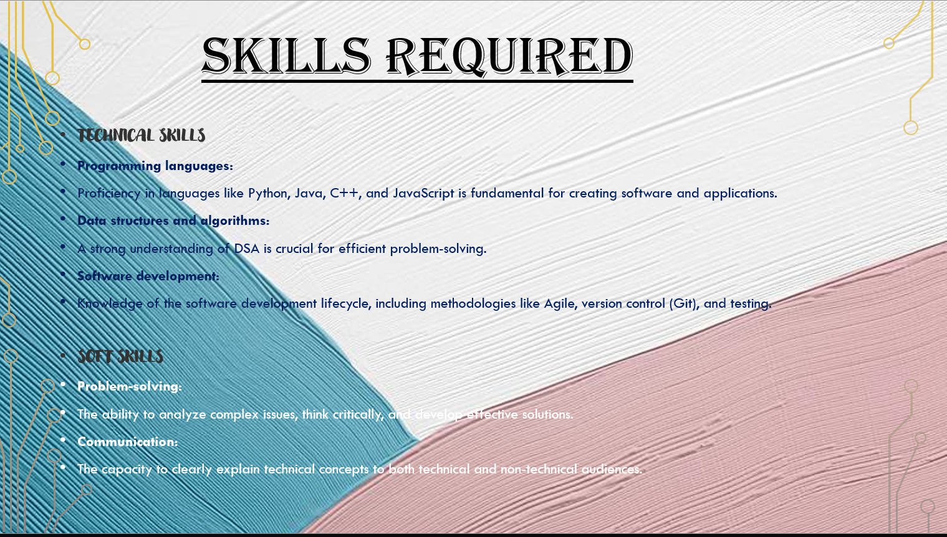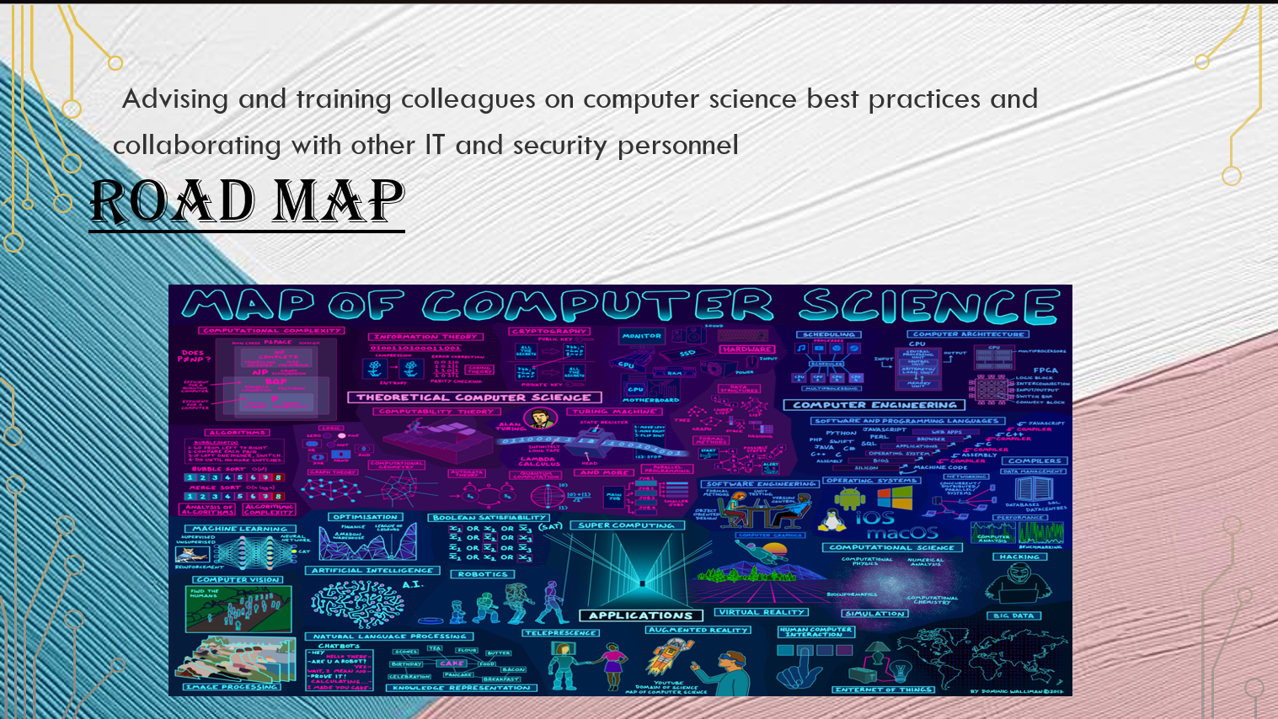



# Practical 3: Digital Awareness Poster in Canva

Aim:

To design a poster for Digital Awareness Week using Canva.

Objectives:

* To apply design tools
* To create a visually appealing poster

Materials Required:

* Canva account
* Computer with internet

Procedure:

# Login to Canva

Open Canva in your browser and sign in using your email or Google account. This gives you access to all templates, design tools, and editing features.

# Select poster layout

Search for “Poster” in the template section and choose a suitable layout.

This layout provides a ready-made design structure to begin your poster.

# Add “Digital Awareness Week” text

Insert a text box or edit the existing heading and type “Digital Awareness Week.” Adjust the font style, size, and alignment to make the title prominent.

# Insert icons and graphics

Go to the “Elements” tab to add icons, shapes, and relevant graphics.

Position them creatively to enhance the visual appeal and message of the poster.

# Apply suitable colors

Choose a color theme that matches the topic and improves readability. Use consistent color combinations for background, text, and elements.

# Download final poster

Click the “Download” button and select the preferred file type, usually PNG or PDF. Save the poster to your device for printing or sharing

# ~OUTPUT~

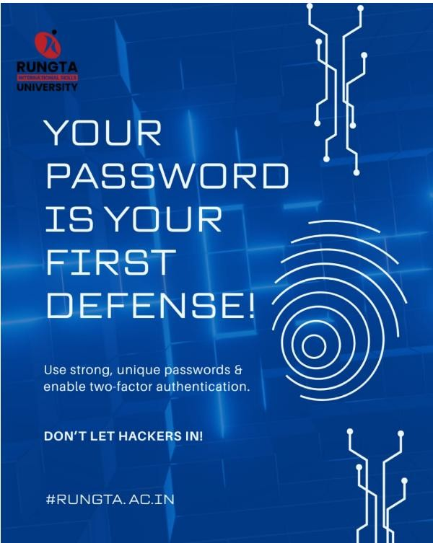

# Practical 4: Professional Email (Internship Application)

Aim:

To draft and send a professional internship email with attachment.

Objectives:

* To compose a professional email
* To attach documents

Materials Required:

* Email account
* Resume file

Procedure:

# Open Gmail

Go to the Gmail website or app and log in with your email account.

This opens your inbox where you can create and send emails.

# Click Compose

Select the **“Compose”** button to open a new email window.

A blank message box will appear on the screen.

# Write subject line

Enter a clear and concise subject that reflects the purpose of the email. This helps the recipient understand the message at a glance.

# Write professional message

Type a polite, well-structured message addressing the recipient formally. Keep the tone respectful and include necessary details or requests.

# Attach resume

Click the **attachment (paperclip)** icon and select your resume file from your device. Ensure the resume is in PDF format and properly named.

# Send email

Review the email for accuracy and ensure attachments are included.

Click **“Send”** to deliver the message to the recipient

# ~OUTPUT~

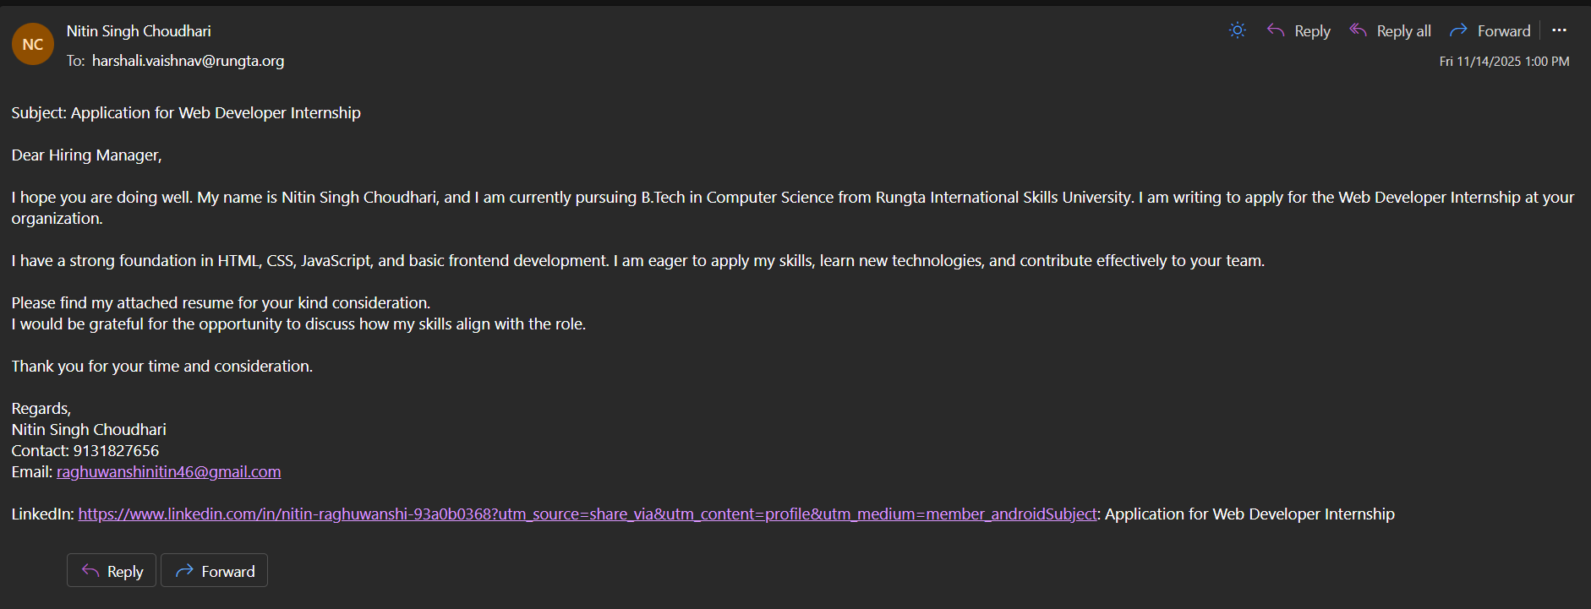

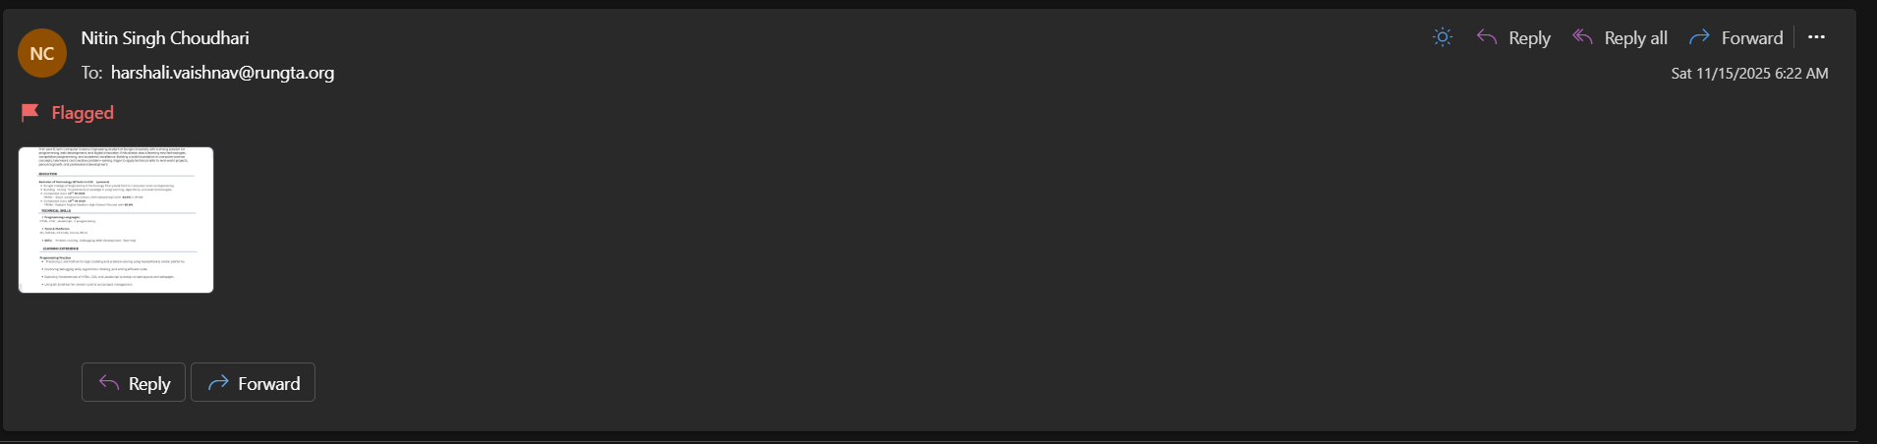

# Practical 5: Create Google Form – Attendance Report

Aim:

To design a Google Form and analyze responses.

Objectives:

* To create form with multiple question types
* To collect sample responses
* To analyze responses

Materials Required:

* Google account
* Internet

Procedure:

# Create new Google Form

Open Google Forms from your Google account and click **“Blank Form”** to start a new form. This opens an empty form where you can add questions.

# Title it “Student Attendance Report”

Enter the title at the top of the form and add a short description if needed. This helps respondents understand the purpose of the form.

# Add MCQs, rating, checkbox and short answer

Use the question type menu to insert multiple-choice questions, rating scales, checkboxes, and short-answer fields.

Arrange the questions in a logical order for easy response.

# Customize theme

Click the **Theme** icon to change colors, fonts, and header images.

This improves the appearance and makes the form visually appealing.

# Share form and collect responses

Use the **Send** button to share the form via link, email, or QR code. Allow participants to submit their responses through any device.

# View summary charts

Go to the **Responses** tab to see automatic charts and graphs generated by Google Forms. These visual summaries help you quickly analyze the collected data.

# Take screenshots

Capture screenshots of the form, responses, and charts for documentation.

Save them for use in reports or practical records.

# ~OUTPUT~

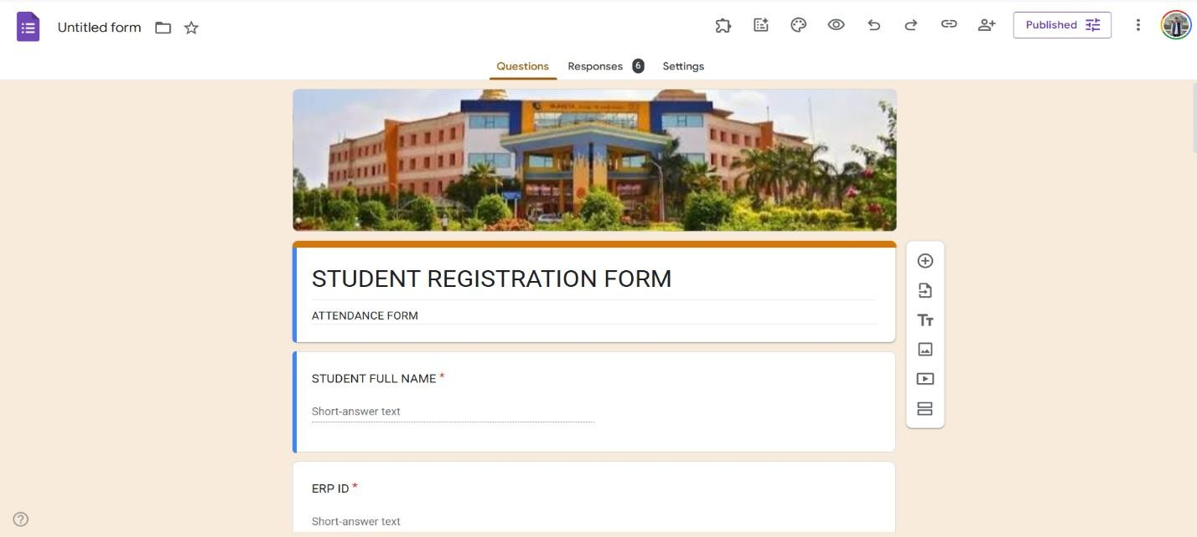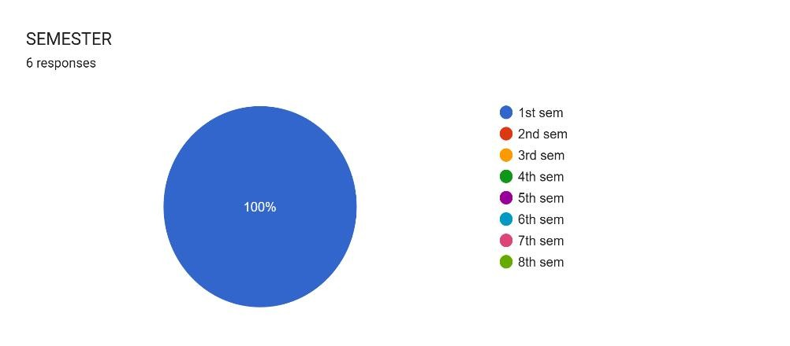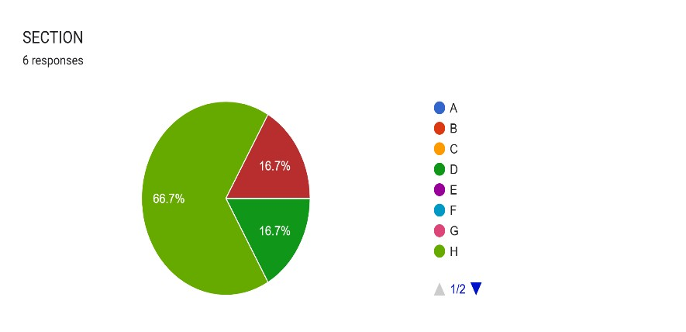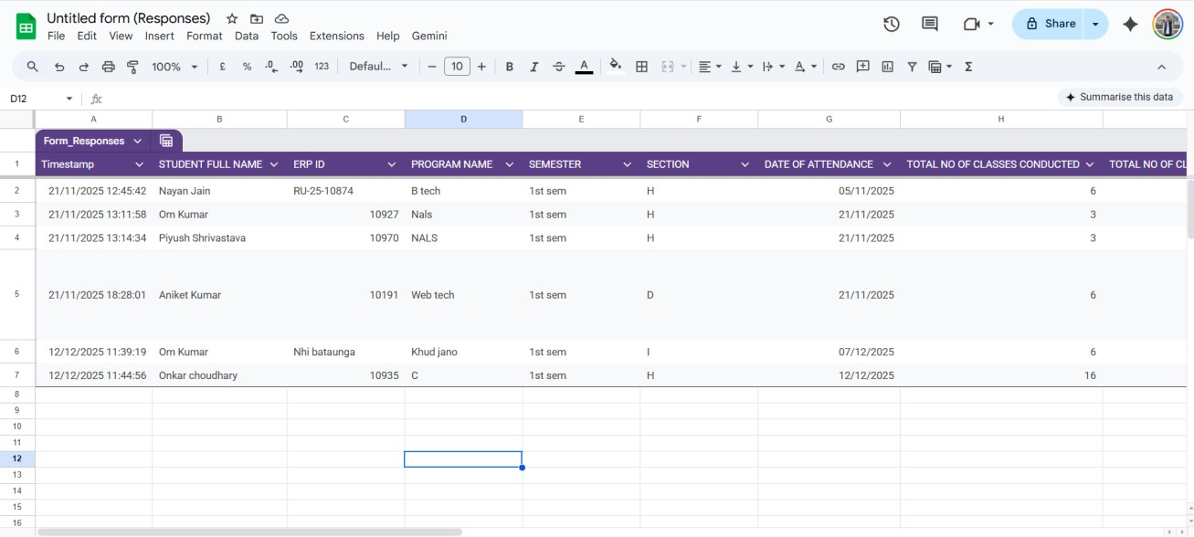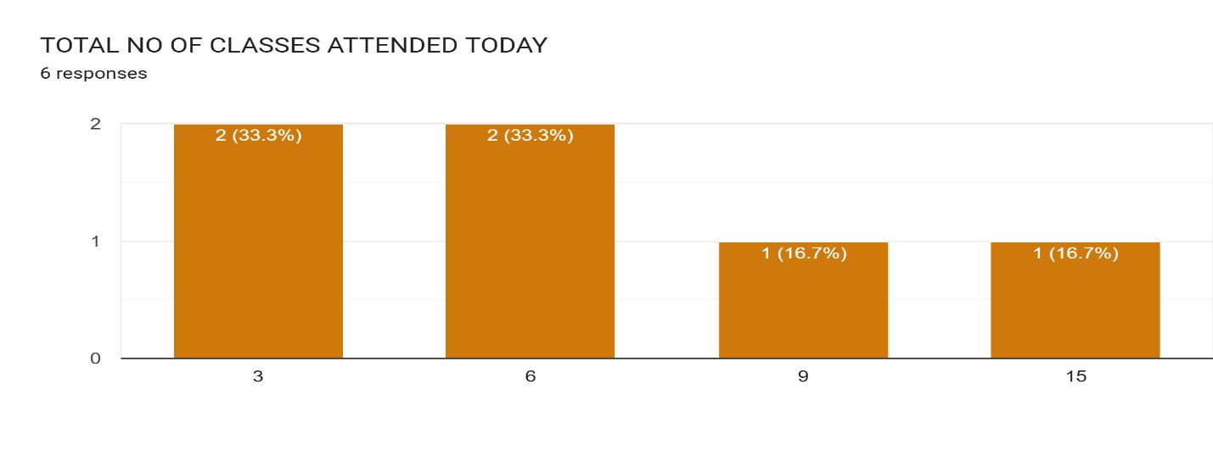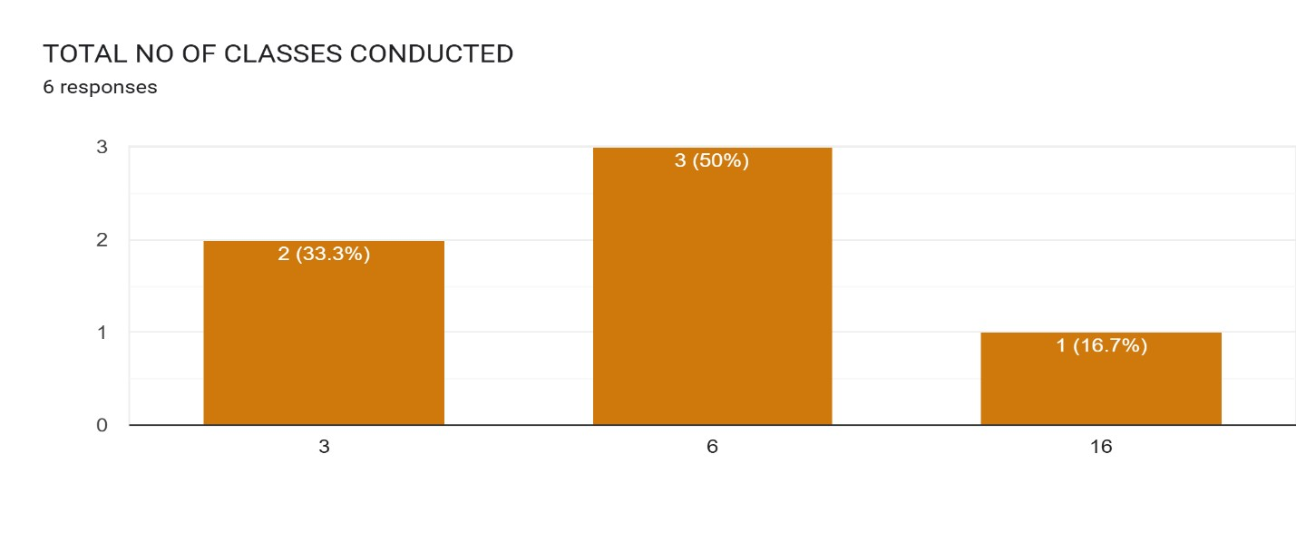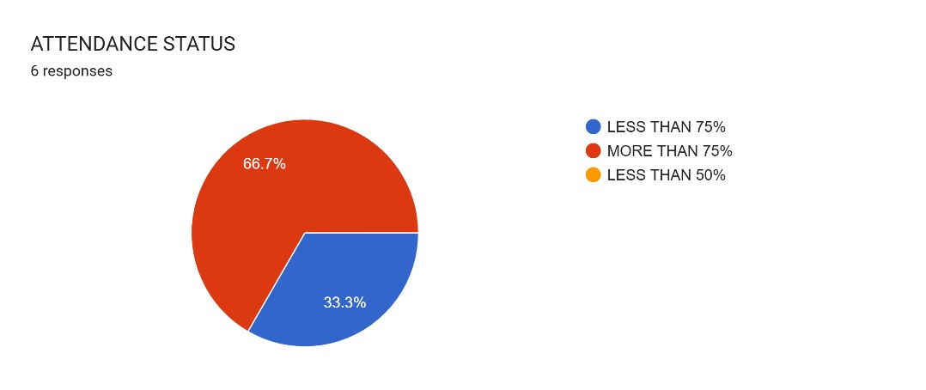

# Practical 6: Create Digital Identity – LinkedIn

Aim:

To create and modify digital identity using LinkedIn.

Objectives:

* To create professional online profile
* To update personal information

Materials Required:

* LinkedIn account

Procedure:

# Create LinkedIn profile

Sign up on LinkedIn using your email and set up a new profile.

This gives you access to professional networking and career-building tools.

# Add photo, bio, education

Upload a clear professional photo and write a short bio summarizing who you are. Enter your educational details to complete your basic profile information.

# Add skills

Use the “Skills” section to list your technical and soft skills.

Adding relevant skills increases your visibility and strengthens your profile.

# Create a simple post

Click “Start a Post” and write a short, meaningful update or introduction. Share it publicly to begin engaging with your professional network.

# Change privacy settings

Go to **Settings & Privacy** to adjust what others can see on your profile.

Modify visibility, contact preferences, and data-sharing options as needed.  **~OUTPUT~**

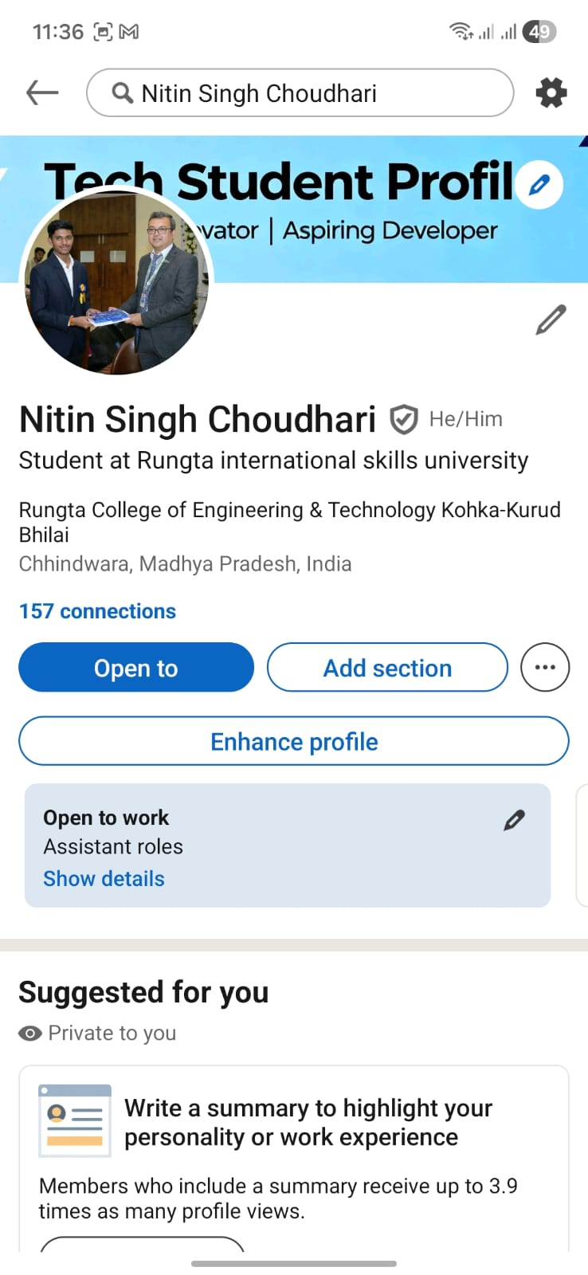

# Practical 7: Using Google Drive / OneDrive

Aim:

To upload and organize files in cloud storage.

Objectives:

* To manage files online
* To share files securely

Materials Required:

* Google Drive / OneDrive account

Procedure:

# 1. Create folder “Unit 3 Practical Work”

Open Google Drive or your file manager and create a new folder named **“Unit 3 Practical Work.”**

This folder will store all files related to the practical.

# 2. Upload documents

Click the **Upload** option and select the required documents from your device. The files will be saved inside the main folder for easy access.

# 3. Create subfolders

Inside the main folder, create additional subfolders to categorize your documents. This helps keep your work organized and easy to locate.

# 4. Share main folder with View only

Right-click the folder, choose **Share**, and set the permission to **View only** for others.

This allows people to see the contents but prevents them from editing or deleting files. **~OUTPUT~**

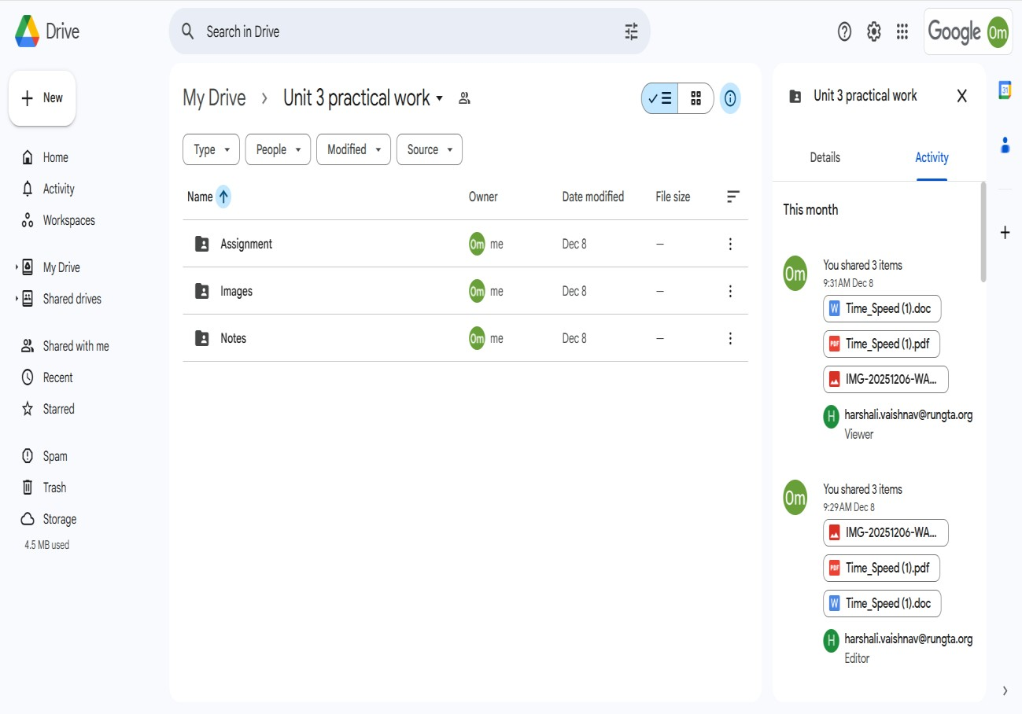

# Practical 8: Identify Phishing Attack

Aim:

To identify phishing attempts through digital messages.

Objectives:

* To detect cybercrime
* To recognize scam elements

Materials Required:

* Provided phishing example

Procedure:

# Read message text

Carefully go through the entire message to understand its content and intent. Make note of any unusual requests or unfamiliar senders.

# Identify suspicious elements

Look for spelling errors, urgent demands, unknown links, or too-good-to-be-true offers. These signs often indicate potential scams or malicious intent.

# List cybercrime type

Based on the suspicious elements, categorize the message as phishing, fraud, malware attempt, etc.

This helps in understanding the nature and threat level of the cybercrime.

# Write verification steps

Suggest ways to confirm authenticity, such as checking the sender’s email, contacting the official source, or scanning links.

These steps help prevent falling victim to cyberattacks.

# ~OUTPUT~

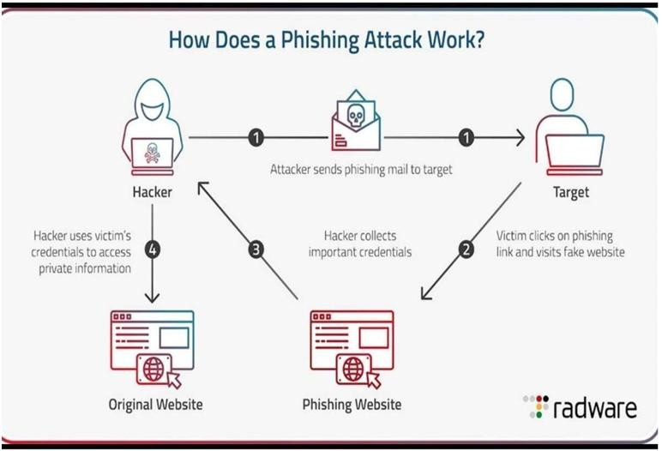

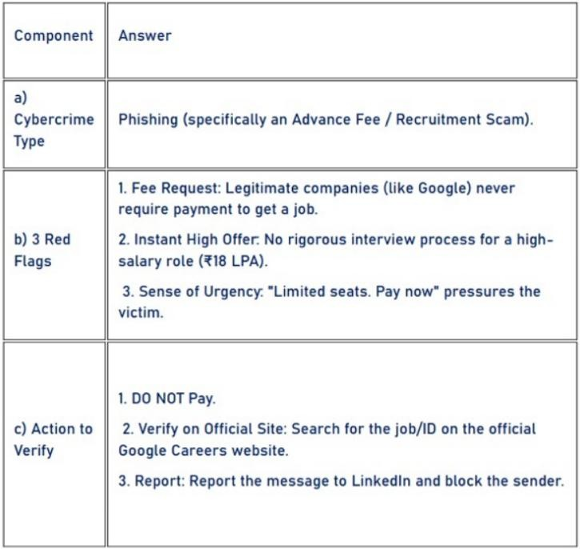

# Practical 9: Google Form Quiz with Timer

Aim:

To create a quiz with automatic grading and time limit.

Objectives:

* To automate quiz assessment
* To use time limit add-on

Materials Required:

* Google Forms
* Timer add-on

Procedure:

1. Create Google Form – Open Google Forms and start a new blank form to set up the structure of your activity.

1. Convert to quiz – Enable “Make this a quiz” in the settings so you can assign points and correct answers.

1. Add 5 MCQs + 1 short answer – Insert five multiple-choice questions and one short-answer question, customizing options and points.

1. Enable 1-response limit – Turn on “Limit to 1 response” so each user can submit the form only once.

1. Shuffle questions – Activate the shuffle feature to randomize the order of questions for every respondent.

1. Add timer add-on – Install a timer add-on from the Add-ons menu to set and control the quiz duration.

1. Send link – Use the “Send” button to generate and share the form link with participants. **~OUTPUT~**

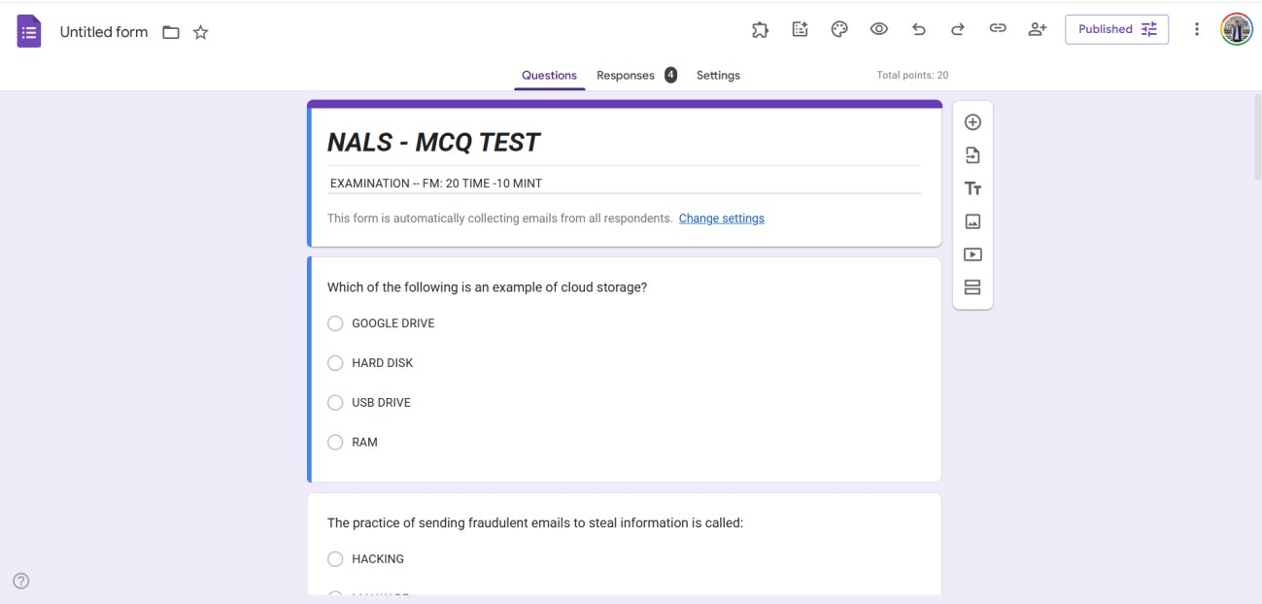

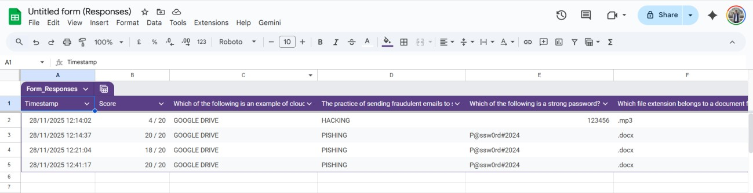

# Practical 10: AI Text Bias & Plagiarism

Aim:

To analyze AI generated text for plagiarism and bias.

Objectives:

* To detect biased statements
* To improve writing

Materials Required:

* ChatGPT / Gemini
* Grammarly

Procedure:

1. Generate paragraph from AI – Use an AI writing tool to produce a clear, coherent paragraph on your chosen topic.

1. Check plagiarism – Run the paragraph through a plagiarism checker to ensure originality and proper attribution.

1. Check grammar – Review the text with a grammar tool to correct errors in punctuation, spelling, and sentence structure.

1. Identify biased statements – Examine the content for subjective language, assumptions, or one-sided viewpoints.

1. Rewrite neutrally – Revise the paragraph to remove bias, ensuring the tone is balanced, objective, and fact-based.

# ~OUTPUT~

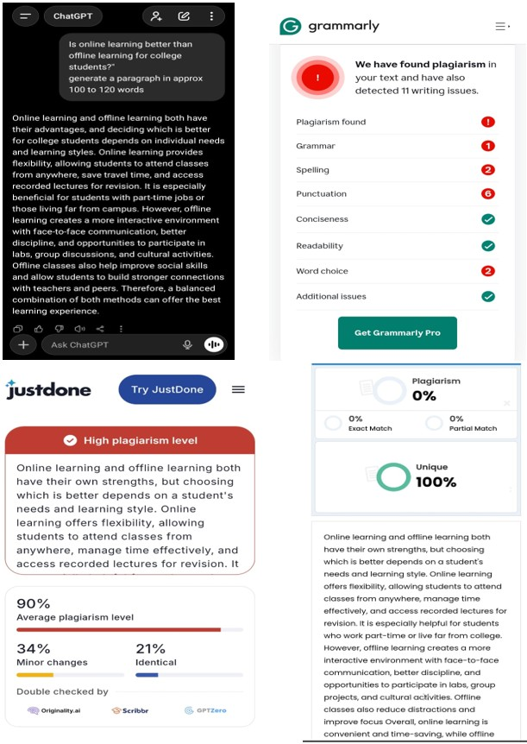

# Practical 11: Compare AI vs Human Writing

Aim:

To compare AI-generated content with student-created content.

Objectives:

* To identify difference in writing
* To understand AI limitations

Materials Required:

* AI tool

Procedure:

1. Write paragraph manually – Compose a paragraph yourself using your own ideas, wording, and structure on the selected topic.

1. Generate same topic using AI – Use an AI tool to produce another paragraph on the same topic for comparison.

1. Create comparison table – Organize both paragraphs side-by-side in a table to compare style, clarity, tone, and content differences.

# ~OUTPUT~

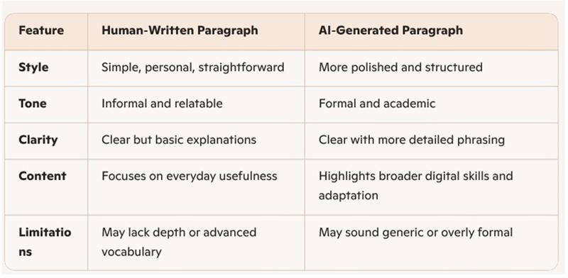

# Practical 12: NotebookLM Project

Aim:

To create revision notes using NotebookLM.

Objectives:

* To generate study guide
* To create flashcards

Materials Required:

* NotebookLM

Procedure:

1. Create NotebookLM project – Start a new project in NotebookLM to organize your materials and AI-generated outputs in one workspace.

1. Upload two resources – Add two documents or sources to the project so the AI can analyze and reference them.

1. Generate study guide – Use NotebookLM’s tools to create a structured study guide summarizing key concepts from the uploaded resources.

1. Generate flashcards – Automatically produce flashcards that highlight important facts, terms, or ideas for easier review.

1. Review accuracy – Carefully check the summaries and flashcards to ensure all information is correct and reflects the original resources.

1. Take screenshots – Capture screenshots of the study guide and flashcards to document your work or include them in your submission.

# ~OUTPUT~

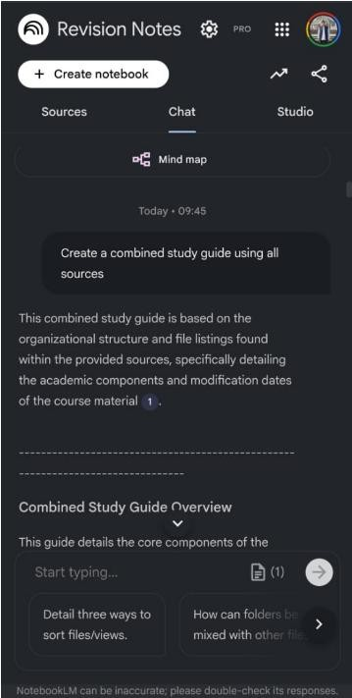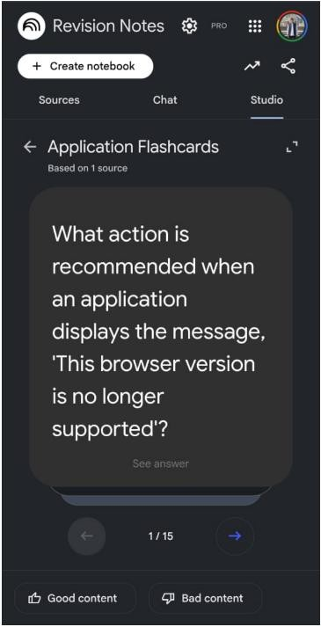

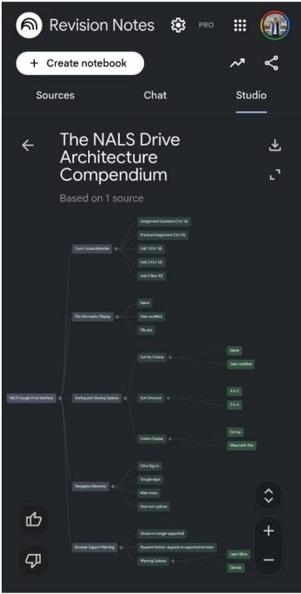

# Practical 13: Excel Student Result Management

Aim:

To analyze student marks using Excel tools.

Objectives:

* To apply Excel formulas
* To create charts

Materials Required:

* MS Excel

Procedure:

1. Enter student data – Input students’ names, marks, and other required details into the spreadsheet.

1. Use Flash Fill – Apply Flash Fill to automatically complete patterns such as separating names or formatting data.

1. Replace incorrect values – Identify errors and use Find & Replace or manual correction to fix inaccurate entries.

1. Calculate pass/fail using IF – Create an IF formula to determine whether each student passes or fails based on their score.

1. Use COUNTIF and AVERAGE – Apply COUNTIF to count specific results and AVERAGE to compute the class’s mean score.

1. Create charts – Generate visual charts to represent student performance trends or score distributions.

1. Apply conditional formatting – Use color-based formatting to highlight important values, such as low scores or top performers.

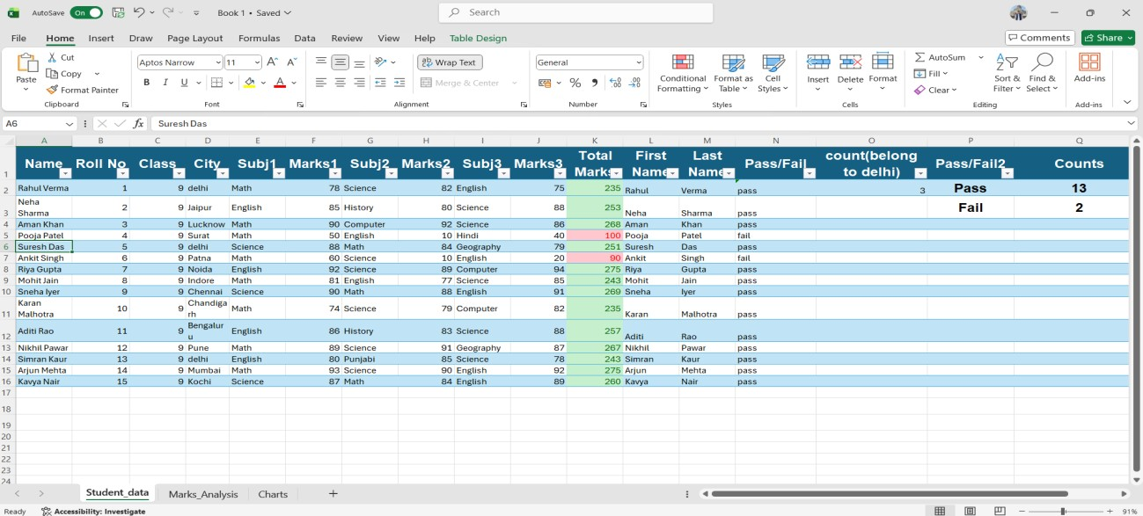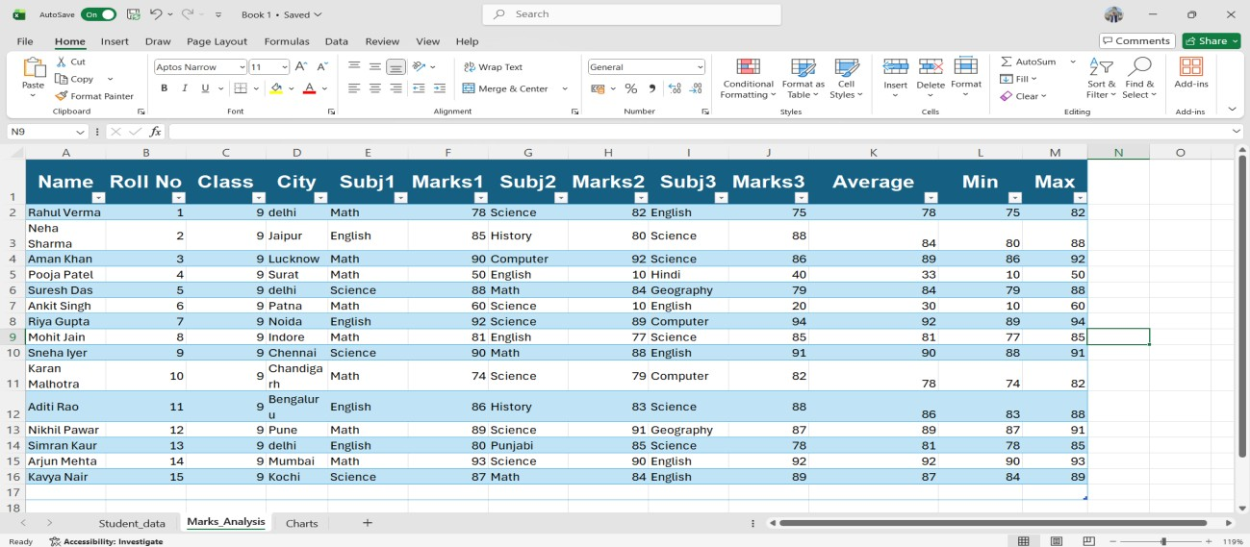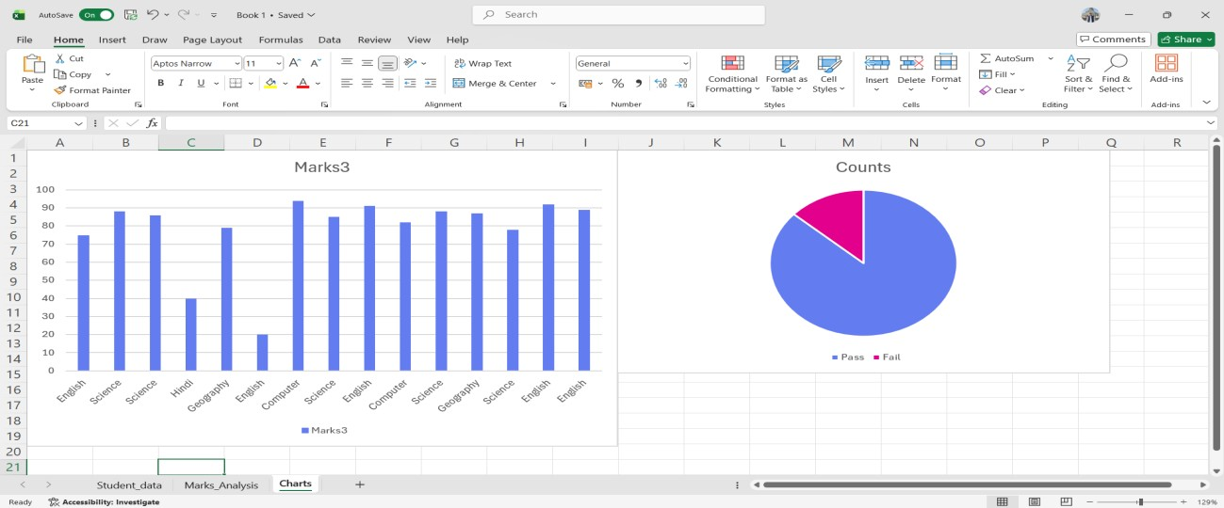

# Practical 14: Sales Data Workbook

Aim:

To analyze sales data using Excel formulas and charts.

Objectives:

* To use SUMIF formulas
* To filter categories

Materials Required:

* Excel

Procedure:

1. Enter or import sales data – Add sales records manually or import them from an external file to build your dataset.

1. Sort and filter – Organize the data by sorting and apply filters to focus on specific products, dates, or regions.

1. Use SUMIF – Apply the SUMIF function to total sales based on a chosen condition, such as product type or salesperson.

1. Extract text using LEFT/RIGHT – Use LEFT or RIGHT functions to pull specific characters from product codes or IDs.

1. Create line chart – Plot a line chart to visualize sales trends over time for clearer analysis.

1. Protect sheet – Lock the sheet or specific cells to prevent unauthorized edits and maintain data integrity.

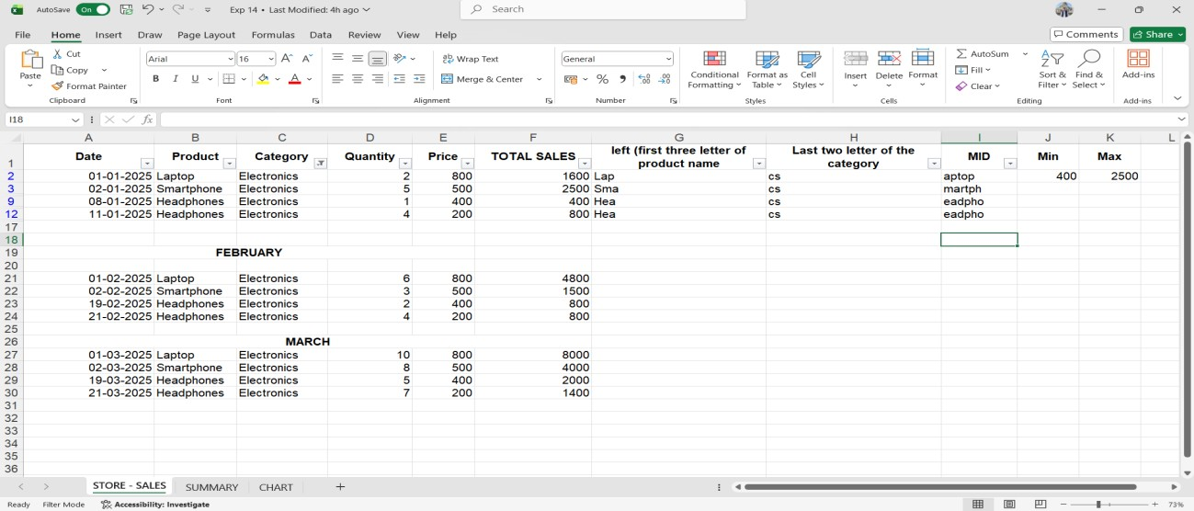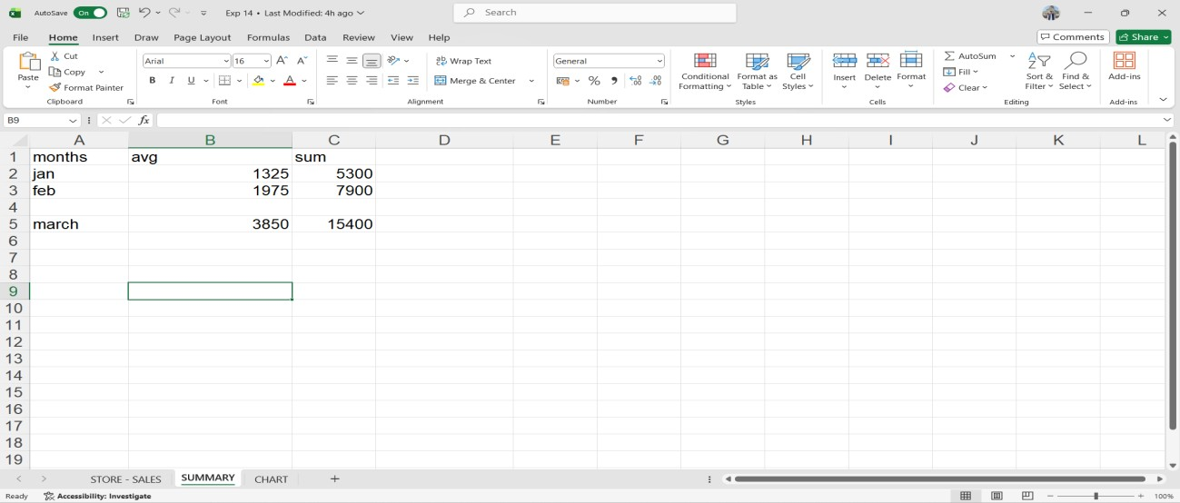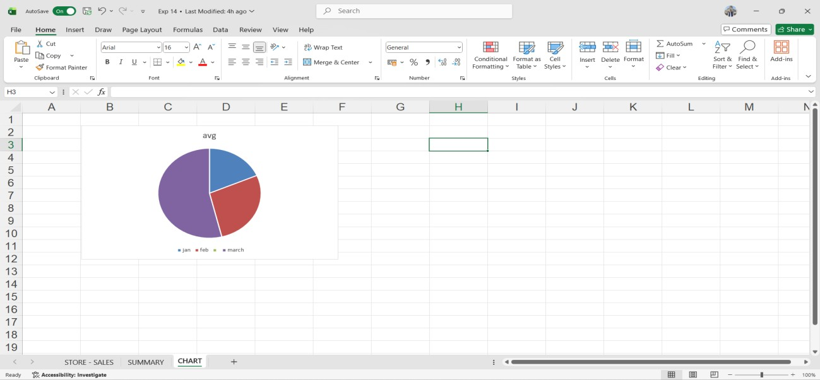

# Practical 15: Personal Financial Planner

Aim:

To prepare a personal financial planner using Excel.

Objectives:

* To track expenses
* To compare budget vs actual

Materials Required:

* Excel

Procedure:

1. Enter expenses – Record all expense items with their categories, dates, and amounts in the spreadsheet.

1. Apply Data Validation – Set validation rules to restrict inputs, such as allowing only numbers or predefined categories.

1. Use SUMIF – Use the SUMIF function to total expenses by category or any specific condition you choose.

1. Create budget sheet – Design a separate sheet comparing planned budgets to actual spending for better tracking.

1. Highlight expenses above limit – Apply conditional formatting to automatically mark entries that exceed your budget limit.

1. Create charts – Generate charts to visually present spending patterns, category breakdowns, or monthly totals.

1. Adjust print settings – Modify page layout, scaling, and margins to ensure the sheet prints clearly and fits on the page.

